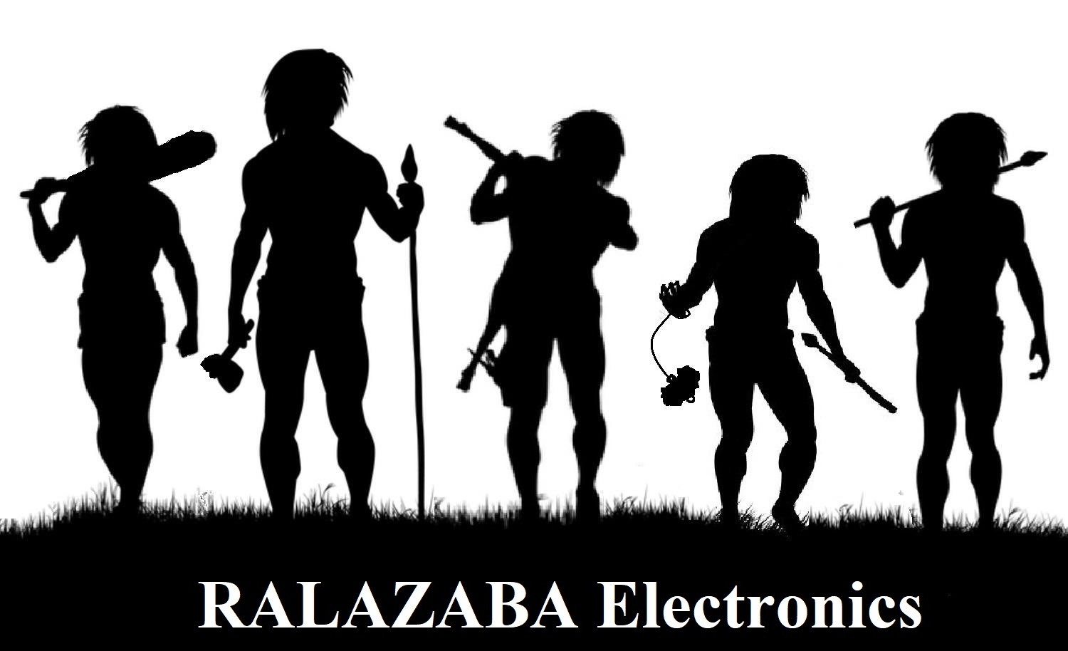

Design Studio Section 9

Business Statement Report

**Advisor**: Lale ALATAN

**Business Partners:**

Ali AYDIN

Anıl AYDIN

Enes AYAZ

Nail TOSUN

Selman DİNÇ

# INTRODUCTION

In this business statement report, we introduced our company and the cofounders of our company with their CV’s. Moreover, we explained four projects from our point of view and we introduced our working schedule which is a 3-week schedule that shows the assignments and work distributions among the company members.

Tentative schedule is in Appendix A.

# INFORMATION ABOUT RALAZABA ELECTRONICS

## Brief History

We established RaLaZaBa Electronics in 2018 while co-founders are Ali AYDIN, Anıl AYDIN, Enes AYAZ, Nail TOSUN and Selman DİNÇ. Everything began with Engineering Design course and we will design and construct one of the project themes defined by our department by adding our own creativity.

## Mission

RaLaZaBa Electronics make the dreams of people real as creating analytical solutions about twenty-one-century issues. We are always one step ahead of the world. Thus, we have unique and practical solutions brought to you.

## Vision

We will unbind our thinking border. We will prepare an easier and happier life thanks to improving our solutions about your wishes. Our motivation is that is done by us until this time. Our aspiration is being the Solution of Things.

## Values

* Teamworking
* Uniqueness
* Flexibility
* Open-mindedness
* Reliability

## Human resources

Our team has an interdisciplinary experience. Anıl Aydın and Selman Dinç chose Electronics option whereas Nail Tosun, Ali Aydın and Enes Ayaz chose Power Electronics area. Other than the core option courses some of the team members take control and computer courses. Besides, all team members have very wide experiences. Anıl Aydın worked on microcontrollers and robotics as well as game design at Unity C#. Ali Aydın, Enes Ayaz are also worked on robotics at IEEE RAS. Enes Ayaz worked on image processes and deep learning algorithms. Ali Aydın and Nail Tosun are work on deep learning algorithms and also attend Autonomous race car organization and took courses on DL and computer vision with Enes Ayaz. Selman Dinç has experienced with RF applications. He has enormous information about sensors and other components which used in robotics applications. He well-informed about CAD tools which are essential in mechanical design. Three of the team members chose Power Electronics area therefore, the team has an advantage on motor control which is, again, critical in robotics.

# PROJECT REDESCRIBTION AND INTERPRETATION

## Devices competing to catch falling balloons

In the first project, we are supposed to catch falling air filled balloons via a device/robot while an opponent robot/device is present and tries to catch the falling balloons. One of the rules for this game is that the competitor robots/devices will not make a physical contact with each other. We are supposed to keep the design in predetermined dimensional constraints. All the subsystems that enable the device functional should fit in the determined dimensions. For demonstrational purpose, a dummy robot that simulates a competitor is required.

During the game, five balloons are dropped by a referee in order and the one that catches the balloon will get the point. After all the balloons are dropped, the winner will be determined by the number of catches. The devices are supposed to catch the balloon before it hits the ground. As the rule suggests, the devices are required to sense its surrounding and the balloons. Moreover, they must be equipped with collision avoidance system.

Moreover, the subsystems to sense environment and to catch balloons should fit into the predetermined. Also, any interference between the sensors of the competitors should be prevented for robust operation.

## Devices trying to score in each other’s goals

In this project, there are two robots that are trying to score by shooting a ball to the opponent’s goal in a hexagonal platform. We are supposed to design and construct one of the competitive robots to goal according to rules. The robot needs some mechanical tools to push or hit the ball to other side.

One of the important necessities for this project is to be able to design transmitter-receiver systems for remote controlling the robot and for monitoring the playfield. We need to transmit our commands to robot and the robot needs to receive our commands to operate them. Some command examples can be to move in four directions, hit the ball etc. Moreover, the scene of the playfield taken by a camera on robot must be transmitted to a monitor. These transmitter-receiver systems must match the requirements such that the range of controller must be at least 30 meters.

In summary, the connection between the user and the robot must be constructed accurately to be functional in a large distance range and should not be disturbed from the environment.

## Vehicles chasing each other around a closed course with varying properties

In this project, there are two robots and these robots try to catch each other in elliptical path. Then, it which catches other wins. Robots will compete on a road. This road is not a straight road. This road has elliptical shape and width of the road is not constant in all the path. The aim of the project is that a robot should approach the other around 5 cm. While a robot tries to catch the other, it should not get out of the line. If it is, it will lose the race.

Moreover, they who control the motor properly will win since if they control the motor properly, the robot does not get out of line and robot goes faster. Because of this, the construction of driving unit will be very important to be able to stay in path and be fast to win the race. Also, to distinguish the road, image processing should be used. Moreover, to adjust the speed of the robot according to situation of the path is important.

In summary, to construct an accurate driving system and a sensing unit for race path recognition will be determinative for this project.

## Devices trying to extract the plan of their surroundings

At the present time, robotics grow day by day and robots have new features at every turn. For example, robots walk like human instead of moving by using the wheel as the past. Also, one of the important features is ‘sensing environment’ for robots. It is wanted that robots’ sense like human and comprehend their domain or surroundings.

In this project, sensing environment is emphasized. A device or robot is supposed to sense its environment and extracts the plan of its surrounding from this sense. The device rambles on the region that is determined by standards and creates a plan of the region. The plan is sent the computer screen. In addition, it is actually a race. Two devices extract plan of the same region and the aims are to create better plan in minimum time. If it needs to talk about the environment, a region is closed with twelve walls. The walls are 50 cm long. The region includes 8 objects with the shape of cylinders with 10-and 5 cm diameter, square prisms with 7cm edge length and prism with a triangular base of 8 cm edge length. In other respect, the robot is communicated with the computer that shows the plan in one direction. There is no information flow from the computer to the robot. It means that the robot moves with autonomous to extract plan.

Moreover, the mapping is required to some analytical and mathematical algorithm. The robot’s rambles on the region to sense the environment take information about the positions and shapes of the objects. So, there are two data flow from robots. One of them is position information about robot and other is surrounding distance information. These data are mixed with the algorithm to extract plan.

Finally, the project gets up to date with the development of robotics and AI. Also, it needs to base of some algebraic transformation alongside optimization on software.

# CONCLUSION

In this business statement report, we declared company’s vision and mission and values. We specified our team’s skills, capabilities and its potential.

We examine all the projects one by one. We determined the problems and possible solutions. Every possible solution in engineering needs some know-how. Firstly, we set our abilities and experiences at Human Resources header. Then, we compared with solutions needs and had an opinion idea for which projects is best for our company.

All after brain-storming these works will be helpful to take turn the company in the right direction.

# APPENDICES

## APPENDIX A: WEEKLY SCHEDULE



## APPENDIX B: CV INFORMATIONS OF COMPANY MEMBERS